Enemy Stats and Emotes

There is now a new script to attach to each enemy for stats. I made the script similar to the player stats but simpler. You can see the stats below. The Enemy Stats Script also contains an Emote section. The script is designed to work with either a single window at the bottom or separate thought bubbles as the Text UI component can be assigned separately as seen below. 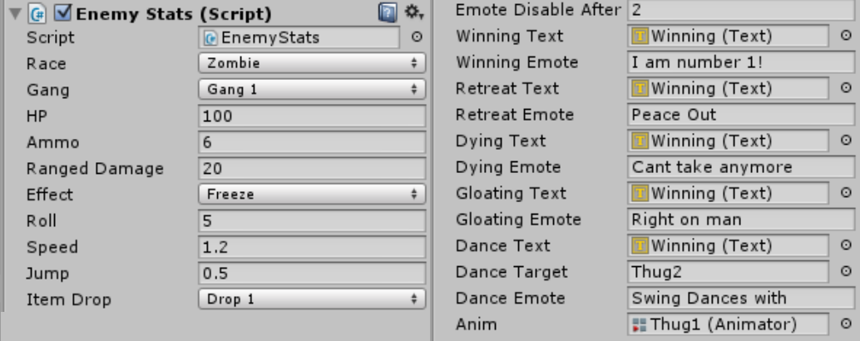

The enemy can also choose a dance "target" to choose to dance with and this will display in the emote. This feature can be added to other emotes if needed.

The system uses the name of the gameObject that it is attached to. For instance if the game object is named Thug1 and the winning emote is "I am number 1" then the box would display "Thug1: I am number 1". If you prefer bubbles and do not want to have the name in the sentence I can easily add a feature to enable or disable it. I have attached a demo where it uses the same text box at the bottom and each enemy randomly selects an emote.

Tied to the script is an animator component. This is part of the enemy AI and each emote can have its own animation. The animation will be triggered in the AI script when it is appropriate to play that emote.